**User Manual**

for E-Katarungan Pambarangay Online System

**Part I. Login/Register**

1. 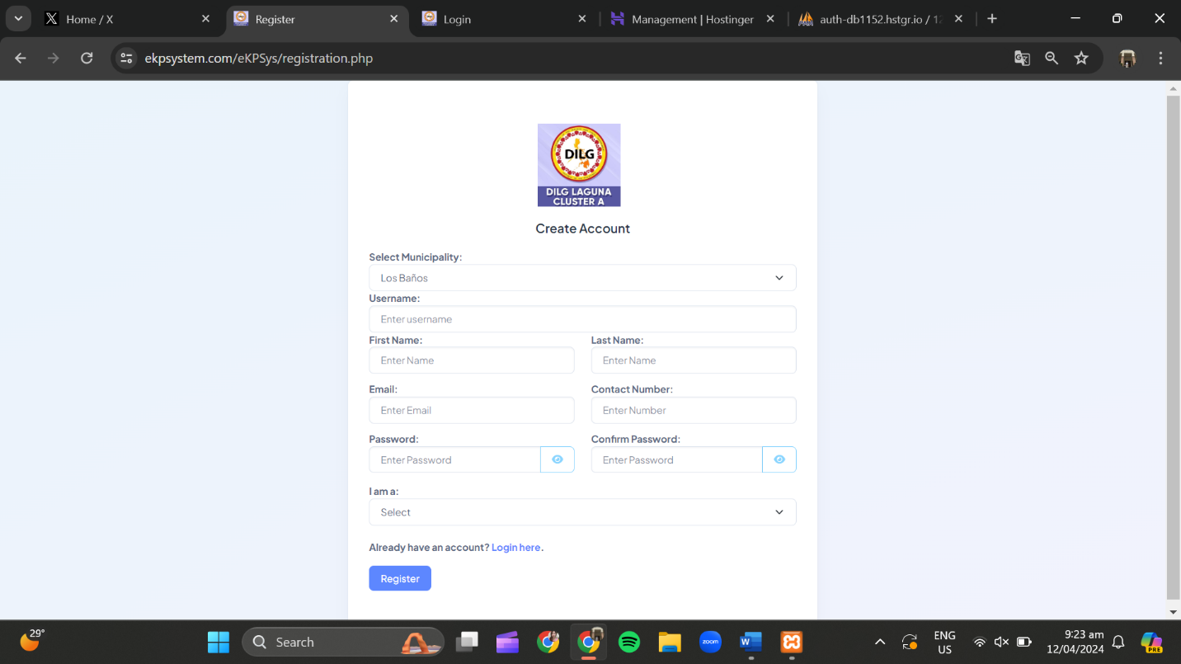To register, go to the link https://ekpsystem.com/eKPSys/registration.php

1.a.  Select your Municipality.

1.b. For username, enter "MLGOO” and your name (Ex. MLGOO Michelle)

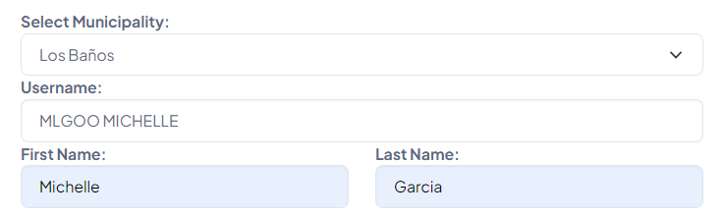1.c. Enter your name

1.d. Enter your email in this format: "c/mlgoo" your “Municipality/City” (Ex. mlgoolosbanos@gmail.com)

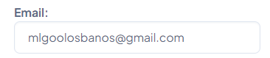

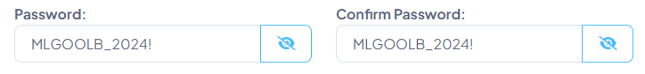1.e. Enter your '11' digit number.  
1.f. Enter a password with minimum of '8' characters including uppercase (A-Z), lowercase (a-z), number (0-9), and special character (!@#$%^&*).

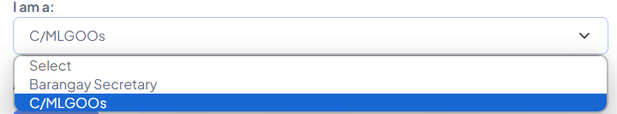1.g. Select your position. For user, choose 'Barangay Secretary' if an C/LMGOO, choose 'C/LMGOOs'.

1. To login, go to https://ekpsystem.com/eKPSys/login.php and login with your email address and password as a user.

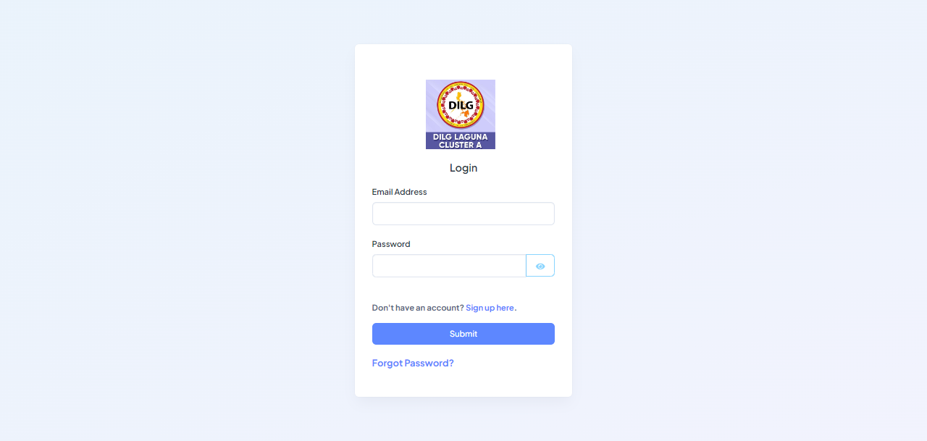­­

1. 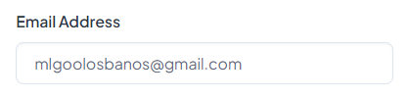Your email address format should look like this:
2. 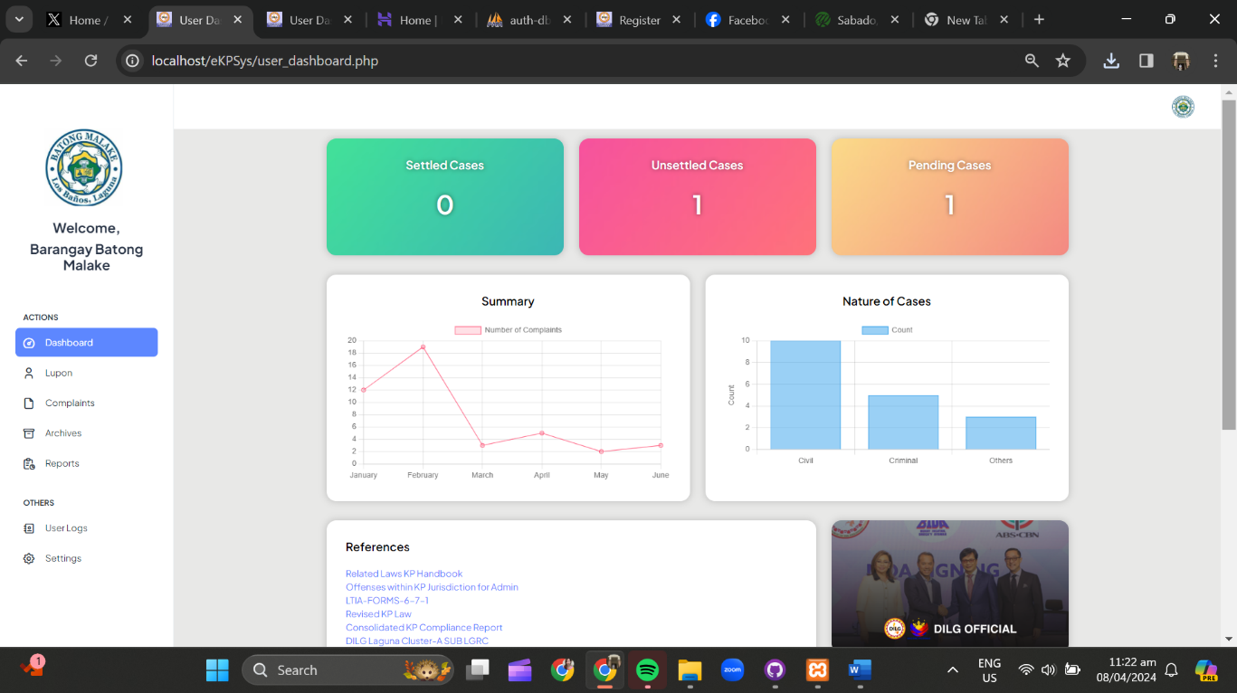After you login, you will see your dashboard. It should look like this:

**Part II. User Settings**

1. The first thing you are required to do is go to settings, scroll to the bottom of the sidebar to see the button “settings”.

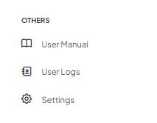

After that, set your account profile picture as your barangay logo, set your first name as “Barangay” and then last name as your barangay name (Ex. First name: Barangay, Last name: Batong Malake). Lastly, set your contact number.

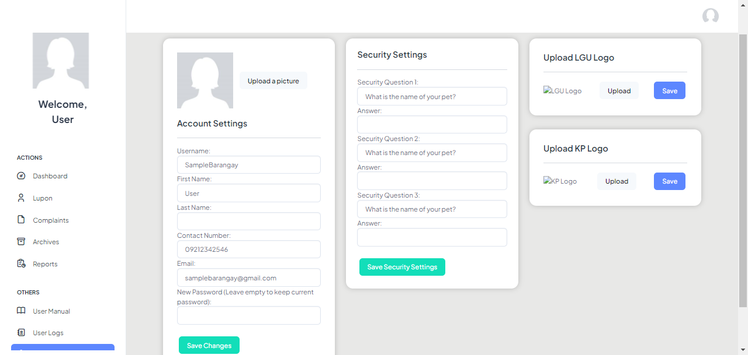For the second part, add and answer security questions to help protect and verify your account. Last is upload and set your official LGU logo and then click save. Do the same with the KP logo.

**Part III. Setting Lupon**

1. After you are done with the settings, the next step is go to Lupon tab to set the names for your Lupon members.

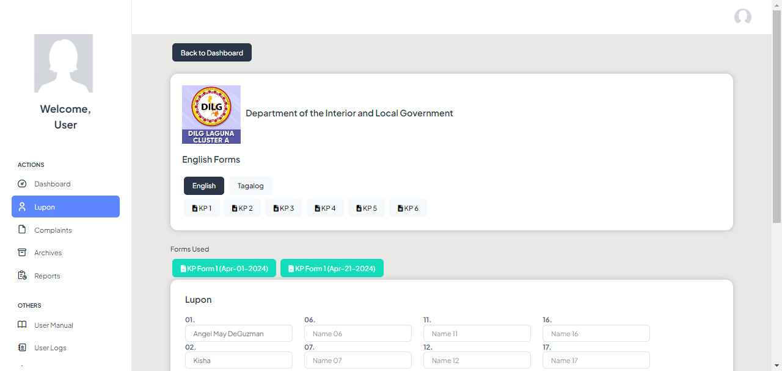

1. When you scroll down, you will see this panel for Lupon, add all your Lupon names, Punong Barangay, and Lupon Chairman, and then click appoint. These names will automatically go to KP Form 1.

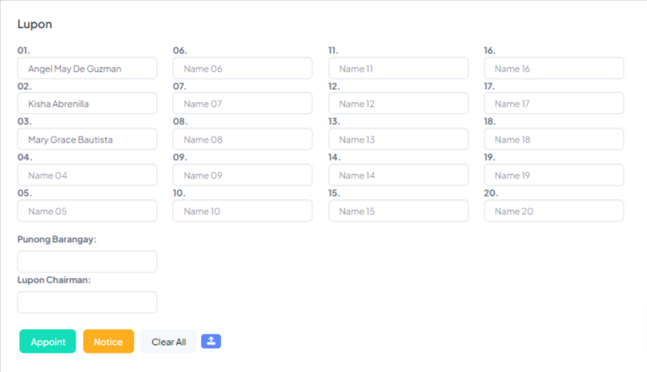

If a Lupon member withdrawn, you can delete the name from the box and then click the “Appoint” button.

**Part IV. Adding a Complaint**

1. Go to the “Complaint” tab on the sidebar.

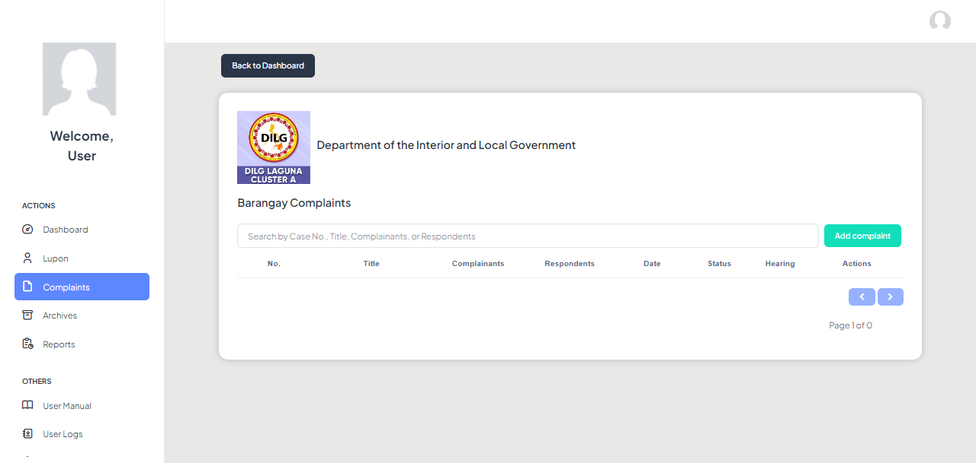

Click the button “Add Complaint” to add a new case. You will see this form after you click it. You need to fill all the required information.

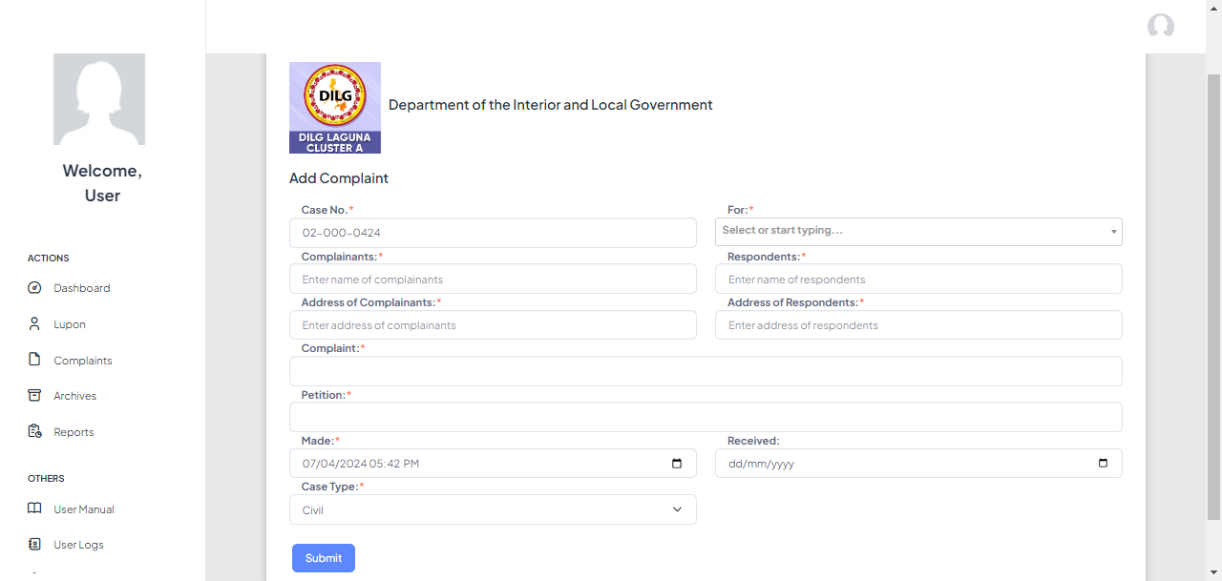

Here, you can modify the case number based on your format. For the title, you can choose to select the given titles in the dropdown, if its ‘others’ just type the title in the box.

1. After filling all the required information, just click “Submit”, and data will be on the complaints table.

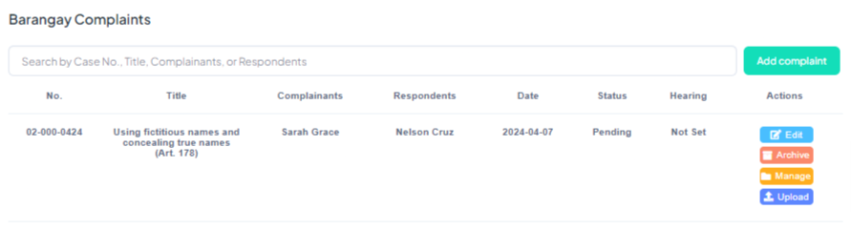

1. To manage a case, you have these options. You can either edit the information of the case, archive the case, manage KP’s, and upload files. You will see these functions in the ‘Actions’ column of the complaint table.  
   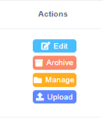
2. Here’s what the manage case looks like, you can check the KP forms of a specific case. You will see its form used, add hearing, and upload all the files that are needed.

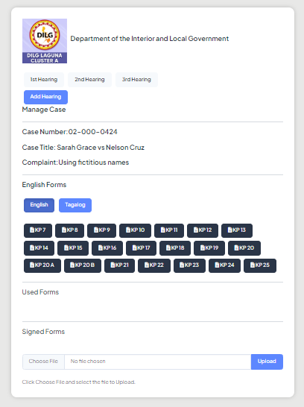

1. To see your archived cases, just go to the ‘Archives’ tab on your sidebar. To unarchive a case, just click the red button.

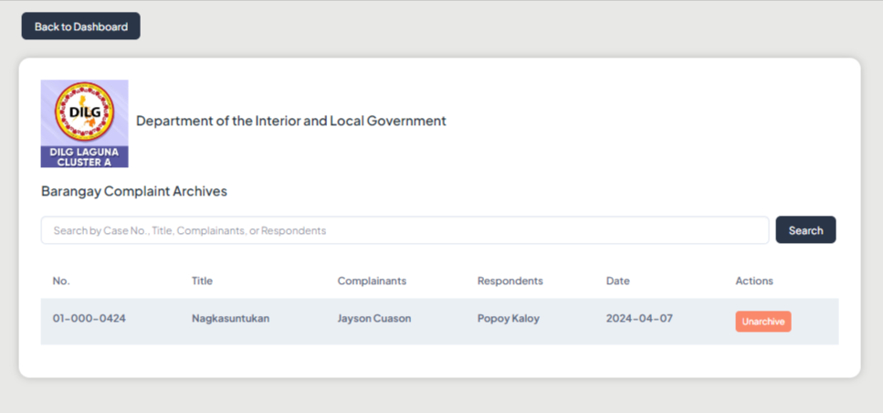

**Part V. Reports**

1. To see the summary of cases, go to the ‘Reports’ tab on your sidebar.

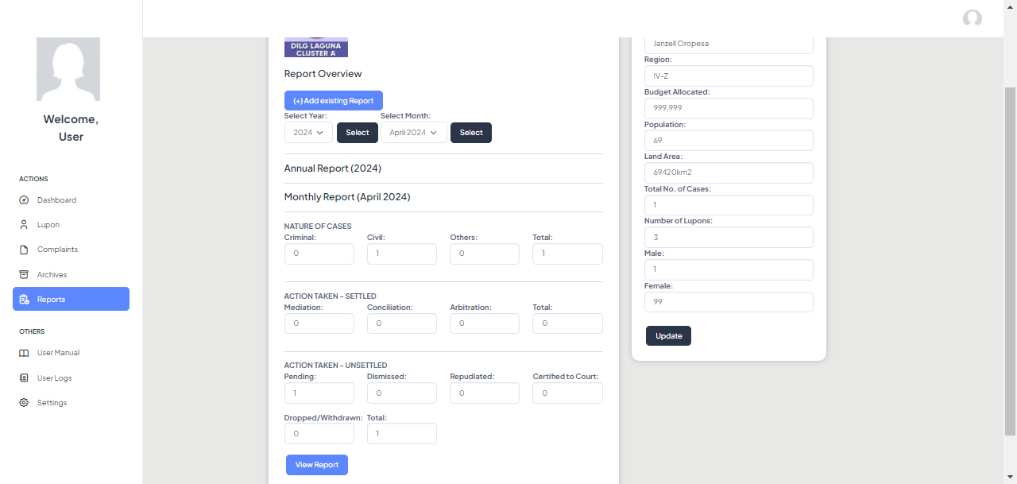

To add an existing data, just click this button.



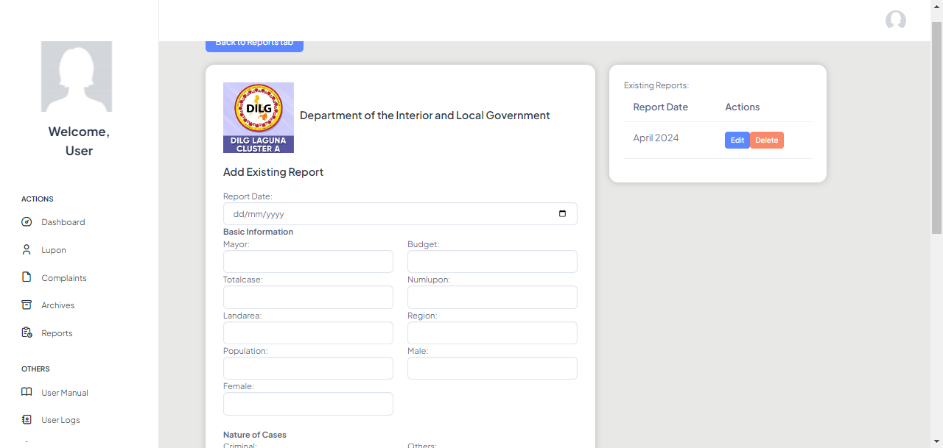

Fill all the required information and then click ‘Submit’. It will automatically be added to your reports overview.

1. To add information on your account, fill up this form, and click update to save it.

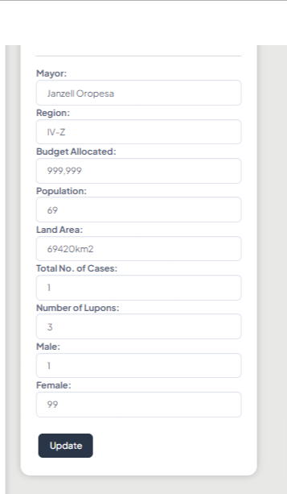

1. To see the report summary in LTIA format, click the ‘View Report’ button.

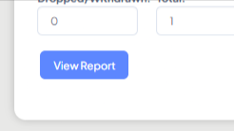

and then you will see this table, you can download it as PDF.

